At the *Night at the Museum*, we explored the exciting world of computer science and art in a fun presentation form. One of the best projects I saw was a computer science project that used APIs to run an Alarm Clock with a stopwatch and time relevant to many different time zones. The most exciting thing about this project was that its APIs were actually created by the group itself. This project was a combination of creativity and collaboration. Another project that caught my eye was an art project.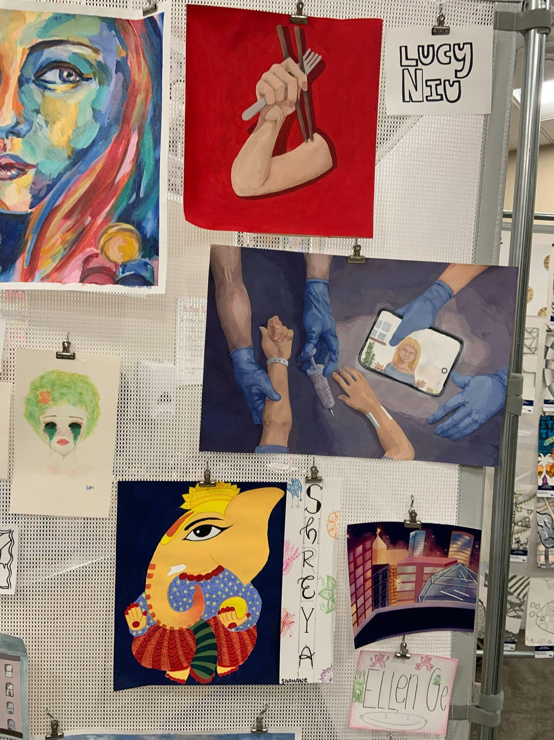

In the center of this panel, there is a very detailed scene of a patient and some doctors. This scene is incredibly detailed, looking like a window into another room with this happening.